
NORTHERN EDUCATION DIVISION MOCK EXAMINATION

2026 MALAWI SCHOOL CERTIFICATE OF EDUCATION

PHYSICS
PAPER I
(100 Marks)

Subject number: M164/I
Tuesday, 24th March Time Allowed: 2 hours
8:00 am – 10:00 am
INSTRUCTIONS:
Question Number | Tick if Answered | Do not write in this column
1
2
3
4
5
6
7
8

9
10
11
12
13

- Write your of name and class on top of each and every page.
- The paper contains two sections; A and B, on 11 printed pages. Please check.
- In section A, there are 10 short answer questions. While in section B, there are three descriptive questions.
- Answer all the questions in the spaces provided.
- Maximum number of marks for each answer is indicated against each question.
- Use of electronic calculators is allowed.
- In the table provided on this page, tick against the number of the question you have answered.
h). Hand in your paper to invigilator when time is called to stop writing.

SECTION A (70 marks)
- (a) Differentiate between a scalar and a vector quantity.
______________________________________________________________________________________________________________________________________________________________
(1 mark)
b. Why is acceleration a vector?
_______________________________________________________________________________ _______________________________________________________________________________
(2 marks)
c. Explain one way on how you can minimize a parallax error.
_______________________________________________________________________________ (1 mark)
d. Convert 20Mg to kg.

(3 marks)
- a. Explain why tractors easily pass through a muddy area without sinking into the ground.
___________________________________________________________________________________________________________________________________________________________________________________________________________________________ (3 marks)
b. Study Figure 1 below and use it to answer the questions that follow.
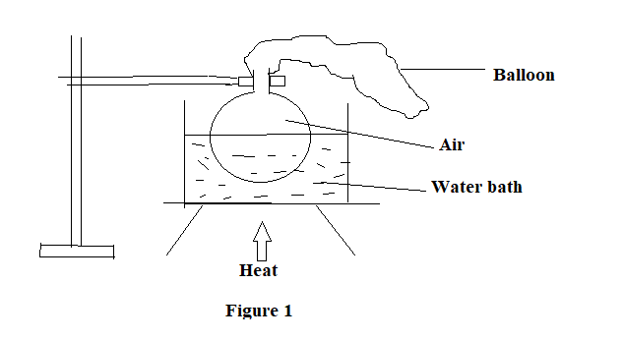
- State what will happen to the balloon when the heat is applied after some time
___________________________________________________________________
(1 mark)
- Explain your answer in 2b(i)
____________________________________________________________________________________________________________________________________________________________________________________________________________________________________________________________________________
(3 marks)
- a. State Faraday’s law of electromagnetic induction.
__________________________________________________________________________________________________________________________________________________ (1 mark)
b. Figure 2 below is a diagram of a transformer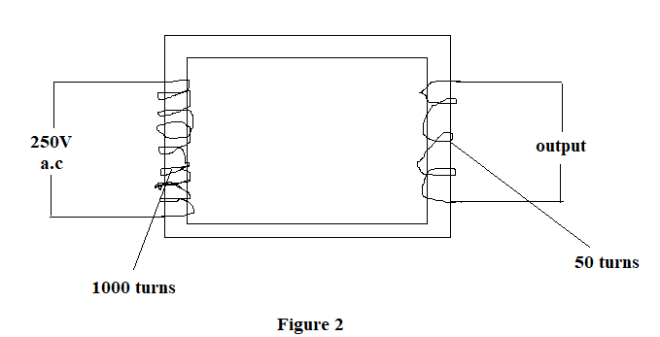
- Name the type of the transformer.
___________________________________________________________________
(1 mark)
- Give a reason for your answer in 3b(i).
___________________________________________________________________ (1 mark)
- Calculate the output voltage of the transformer.

(3 marks)
- State any two ways how the transformer above loses energy.
______________________________________________________________________________________________________________________________________
(2 marks)
- a. Explain how temperature affects the speed of sound in air
___________________________________________________________________________________________________________________________________________________________________________________________________________________________
(2 marks)
b. State any one factor that affects the frequency of a cantilever.
_________________________________________________________________________
(1 mark)
c. Figure 3 is a diagram of a wave
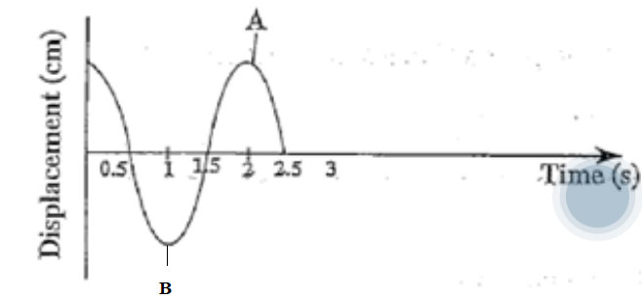
Figure 3
- Name the type of the wave given in figure 3.
___________________________________________________________________
(1 mark)
- Calculate the frequency of the wave

(2 marks)
- Determine the velocity of the wave if its wavelength is 100m

(2 marks)
- a. Explain how the radio waves are detected
_________________________________________________________________________________________________________________________________________________
(2 marks)
b. Figure 4 below is a diagram of a person reading a book
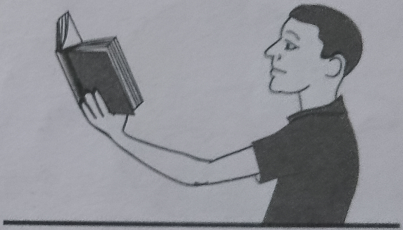S
Figure 4
- Name the defect shown in figure 4.
__________________________________________________________________
(1 mark)
- Explain how the defect in figure 4 occurs.
________________________________________________________________________________________________________________________________________________________________________________________________________
(3 marks)
- State one way in which the defect can be corrected.
___________________________________________________________________
(1 mark)
- a. Differentiate the term Nuclear Fusion from nuclear fission.
__________________________________________________________________________________________________________________________________________________
(1 mark)
b. Mention any one characteristic of radioactive materials
_________________________________________________________________________
(1 mark)
c. The tyre of the bicycle rotated with angular velocity of 65.5rads/sec. Find tangential velocity in km/h on the edge of the tyre with radius 45cm

(4 marks)
- Figure 5 shows a coin and a feather falling through a vacuum.
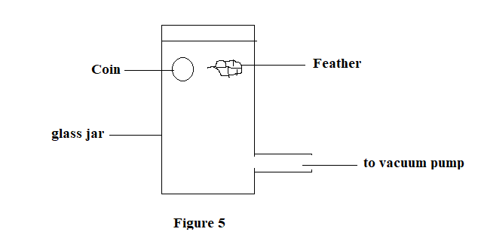
- Which object(s) will reach the bottom of the tube faster, if they were both released at the same time?
_________________________________________________________________________
(1 mark)
- Explain your answer in 7(a) above.
__________________________________________________________________________________________________________________________________________________
(2 marks)
- Give any two reasons why water is not used in hydraulic machines.
__________________________________________________________________________________________________________________________________________________ (2 marks)
- a. Explain how a short circuit occurs.
___________________________________________________________________________________________________________________________________________________________________________________________________________________________
(3 marks)
b. (i). Define the term “internal resistance of a cell”
__________________________________________________________________
(1 mark)
(ii) The potential difference across the terminal of a cell is 1.5V when there is no current in the cell. When there is a current of 0.2A in the circuit, the potential difference falls to 1.4V. Calculate the internal resistance of the cell.

(4 marks)
- a. Figure 6 below is a diagram showing radiations passing through a magnetic field.
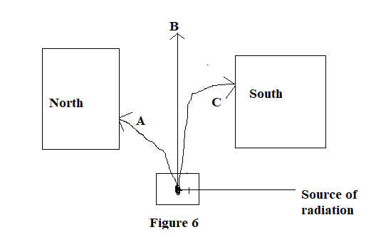
- Name the particle labelled A
___________________________________________________________________
(1 mark)
- Explain why particle C deflects towards the south
______________________________________________________________________________________________________________________________________
(3 marks)
b. Explain why it is important to use radioisotopes with a shorter half-life as tracers in agriculture.
__________________________________________________________________________________________________________________________________________________
(2 marks)
- Figure 7 below shows a symbol of a logic gate, use it to answer questions that follow.
Figure 7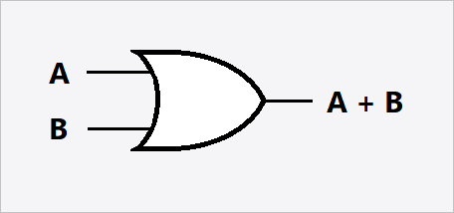
- Name the logic gate given in figure 7 above.
_________________________________________________________________________
(1 mark)
- Draw the truth table for the working of the logic gate named in (a) .
(2 marks)
  - Figure 8. is a diagram of an instrument used to measure gas pressure. Use it to answer the questions that follow.
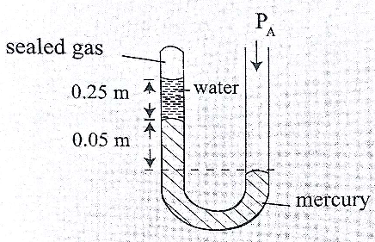figure 8

- Name the instrument.
___________________________________________________________________ (1mark)
ii. If the atmospheric pressure P_{A} is 102,000N/m², density of mercury is 13,600kg/m³ and g = 10N/kg, calculate the pressure of the trapped gas. (Take density of water as 1000kg/m³.

(4 marks)

SECTION B (30 marks)
Answer all the questions from this section.
- a. Describe how you can measure the internal diameter of a small plastic tube.
________________________________________________________________________________________________________________________________________________________________________________________________________________________________________________________________________________________________________________________________________________________________________________________________________________________________________________________________________________________________________________________________________________________________________________________________________
(5 marks)
b. With the aid of a well labelled diagram, explain how Newton’s third law of motion can be applied in agricultural irrigation in Malawi.

_________________________________________________________________________ _________________________________________________________________________ _________________________________________________________________________ _________________________________________________________________________ _________________________________________________________________________ _________________________________________________________________________ _________________________________________________________________________ _________________________________________________________________________ _________________________________________________________________________ _________________________________________________________________________ _________________________________________________________________________ _________________________________________________________________________ (5 marks)
- a. Describe how you can demonstrate atmospheric pressure using a collapsing can experiment.
____________________________________________________________________________________________________________________________________________________________________________________________________________________________________________________________________________________________________________________________________________________________________________________________________________________________________________________________________________________________________________________________________________________________________________________________________________________________________________________________________________________________________________________________________________________________________________________________________________________________________________________________________________________________________________________________________________________________________________________
(5 marks)
b, Using a well labelled diagram describe the destructive wave interference.

_________________________________________________________________________ _________________________________________________________________________ _________________________________________________________________________ ________________________________________________________________________ _________________________________________________________________________ _________________________________________________________________________ _________________________________________________________________________ _________________________________________________________________________ _________________________________________________________________________
(4 marks)
- Using a well labelled diagram, describe an experiment that you could use to determine acceleration due to gravity using a simple pendulum.

____________________________________________________________________________________________________________________________________________________________________________________________________________________________________________________________________________________________________________________________________________________________________________________________________________________________________________________________________________________________________________________________________________________________________________________________________________________________________________________________________________________________________________________________________________________________________________________________________________________________________________________________________________________________________________________________________________________________________________________________________________________________________________________________________________________________________________________________________________________________________________________________________________________________________________________________________________________________________________________________________________________________________________________________________________________________________________________________________________________________________________________________________________________________________________________________________________________________________________________________________________________________________________________________________________________________________________________________________________________________________________________________________________ END OF QUESTION PAPER (10 marks)

